Smart Home Automation(Using Android App)
Description:
Home automation is the fastest-growing technology using in 2020. This is a very Popular project Nowadays and also interesting when you can control your home appliances with your mobile phone. It is pretty simple You should have only the basic knowledge about electronics and microcontrollers.to make this Home automation using Arduino and Bluetooth.

Arduino Uno:
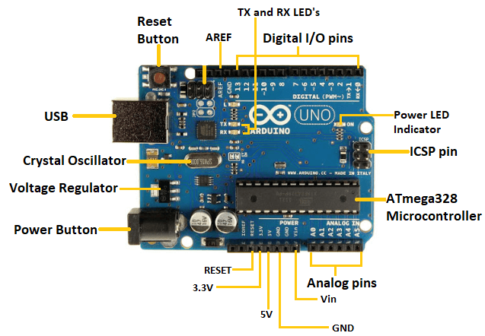
Arduino UNO is a microcontroller board based on the ATmega328P. It has 14 digital input/output pins (of which 6 can be used as PWM outputs), 6 analog inputs, a 16 MHz ceramic resonator, a USB connection, a power jack, an ICSP header and a reset button. It contains everything needed to support the microcontroller; simply connect it to a computer with a USB cable or power it with a AC-to-DC adapter or battery to get started.

Replaceable chip
The ATmega328P can easily be replaced, as it is not soldered to the board.
EEPROM
The ATmega328P also features 1kb of EEPROM, a memory which is not erased when powered off.
Battery Connector
The Arduino UNO features a barrel plug connector, that works great with a standard 9V battery.
Requirments:
- Arduino Uno
- 4 Channel Relay Module
- HC05-Bluetooth Device
- 9VDc Adapter
- External Power 240VAC-/50-60HZ
Relay:

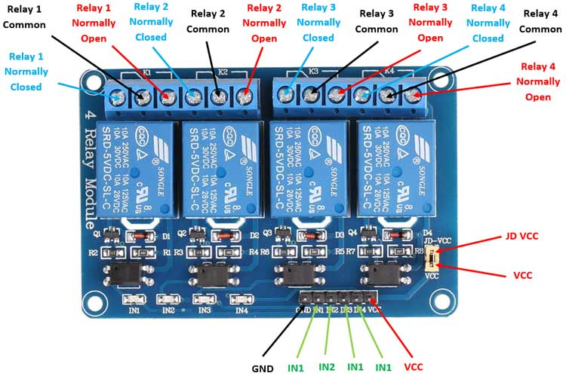

The Relay Module is a convenient board which can be used to control high voltage, high current load such as motor, solenoid valves, lamps and AC load. It is designed to interface with microcontroller such as Arduino, PIC and etc. The relays terminal (COM, NO and NC) is being brought out with screw terminal.
HC05-Bluetooth Module:
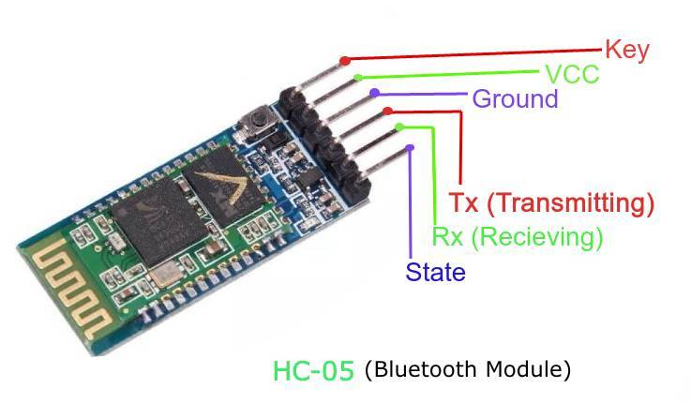
The HC-05 is a class 2 Bluetooth module designed for transparent wireless serial communication. It is pre-configured as a slave Bluetooth device. Once it is paired to a master Bluetooth device such as PC, smart phones and tablet, its operation becomes transparent to the user. All data received through the serial input is immediately transmitted over the air. When the module receives wireless data, it is sent out through the serial interface exactly at it is received.

Circuit Diagram:
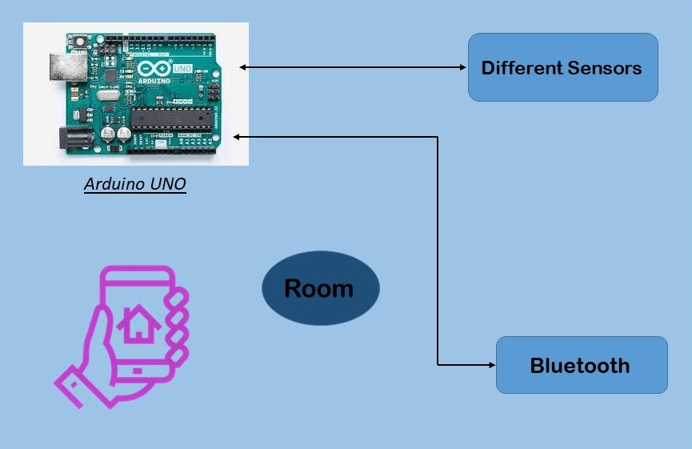
Main Diagram: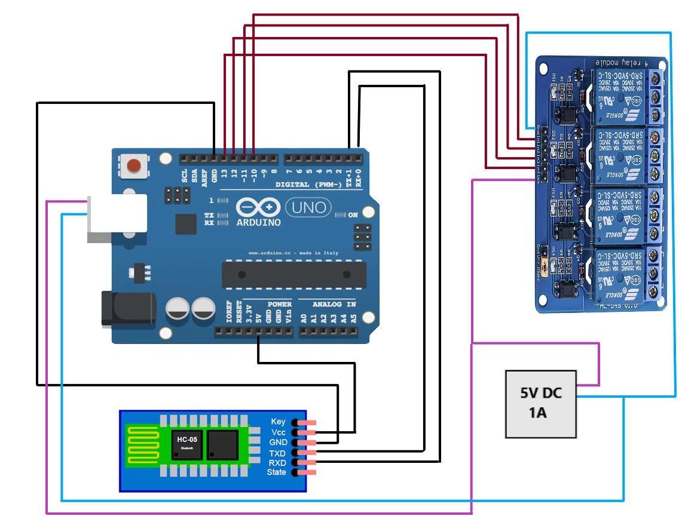
Bluetooth App:
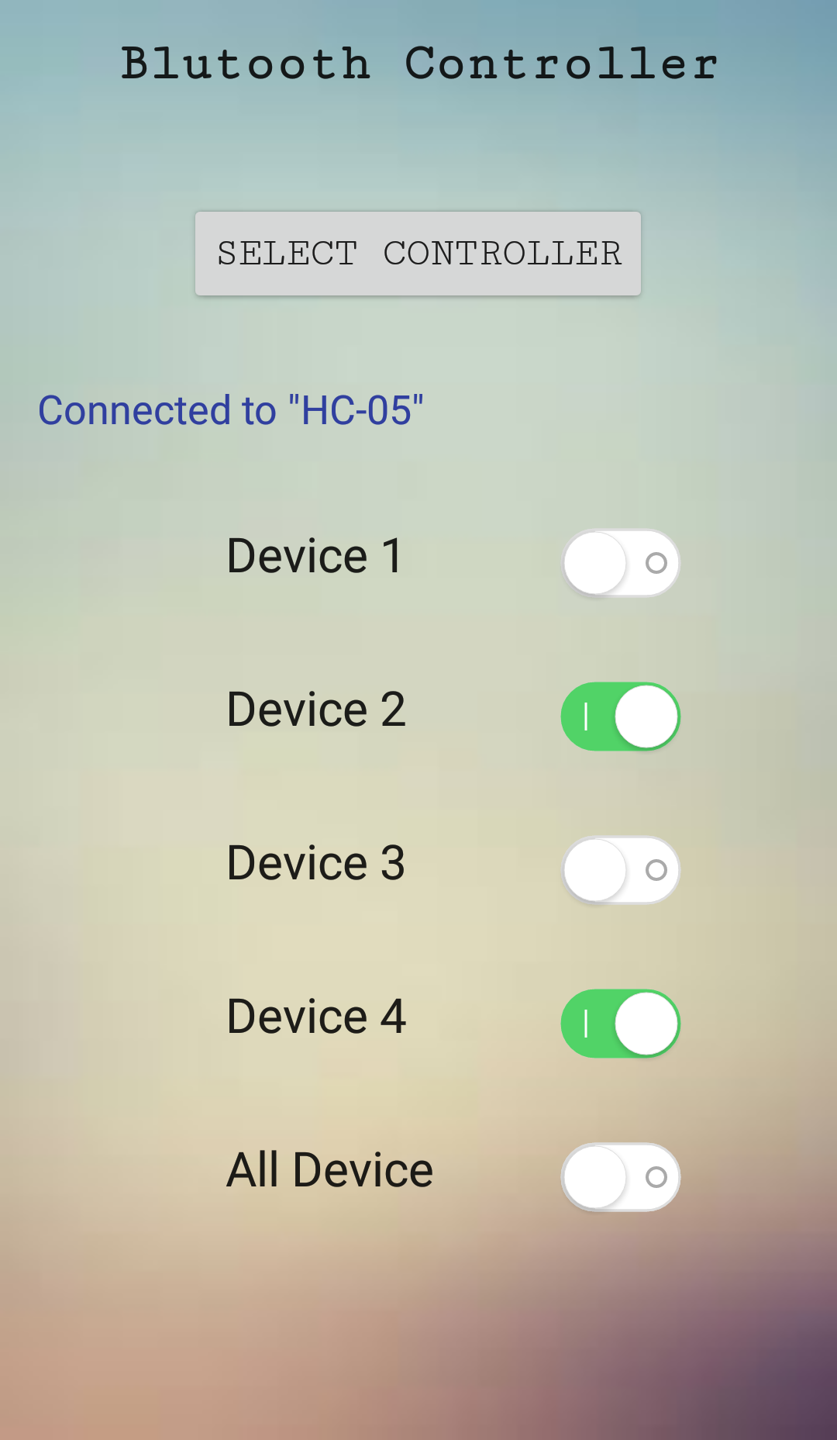

Code:
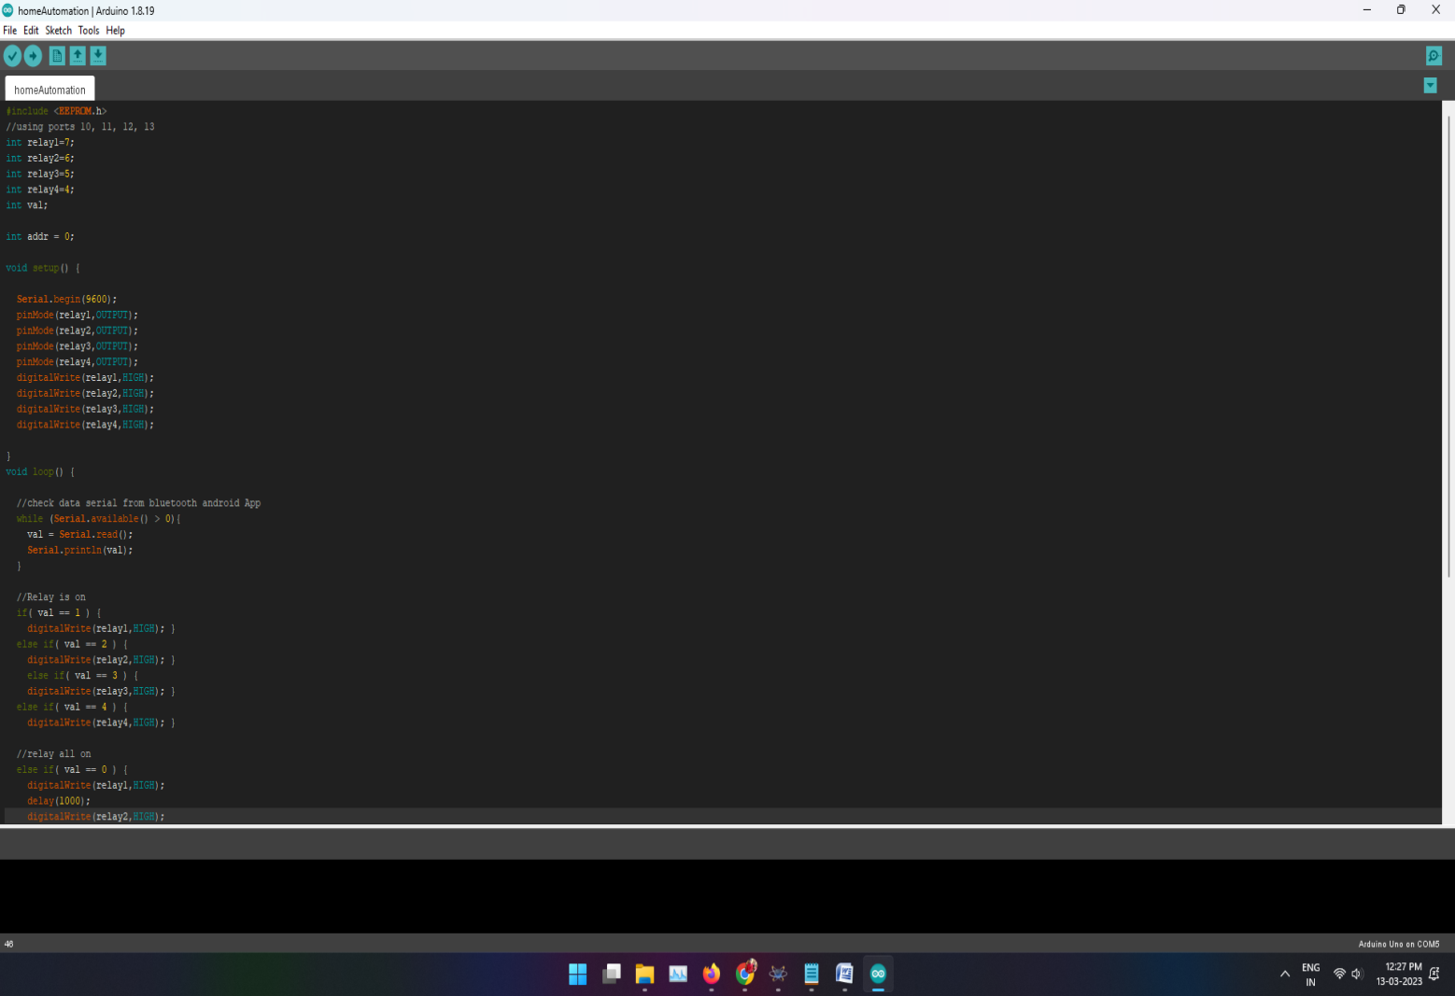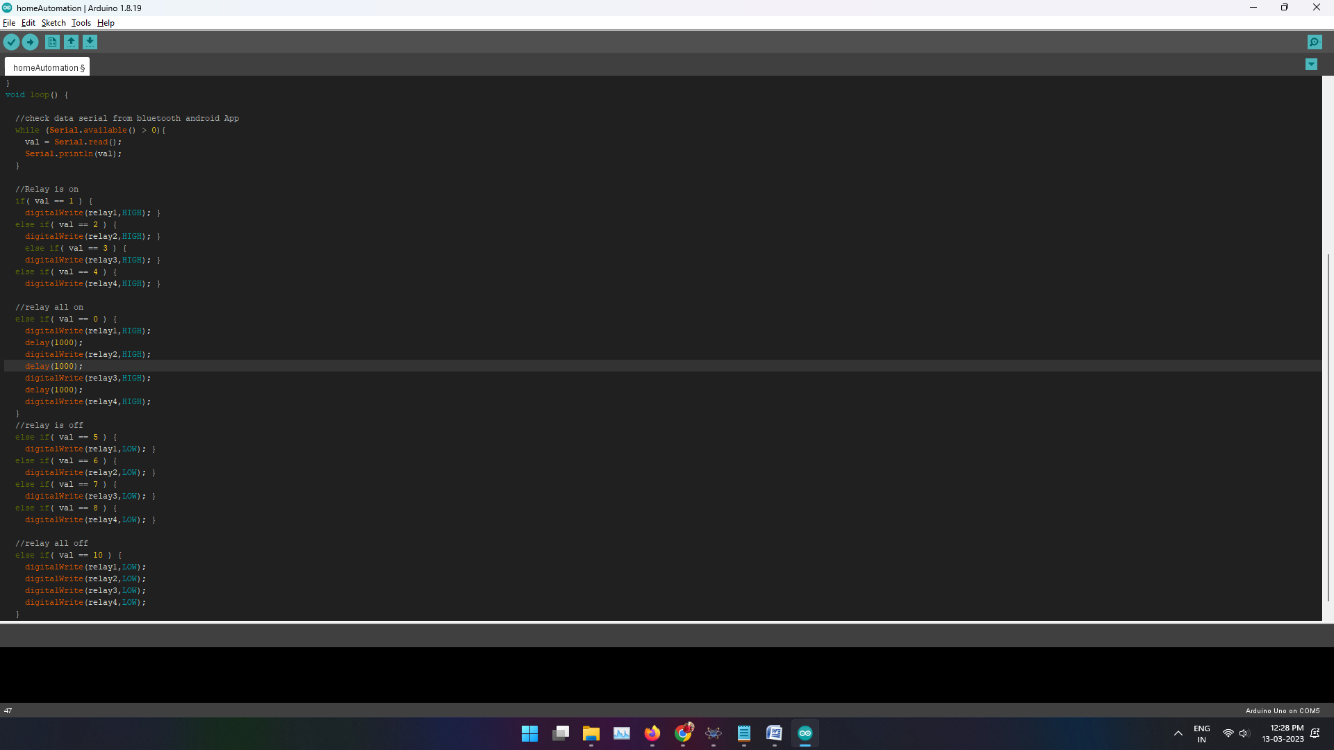

Conclusion:
The system as the name indicates, ‘Home automation’ makes the system more flexible and
provides attractive user interface compared to other home automation systems. In this system
we integrate mobile devices into home automation systems. A novel architecture for a home
automation system is proposed using the relatively new communication technologies. The
system consists of mainly three components is a BLUETOOTH module, Arduino
microcontroller and relay circuits.

